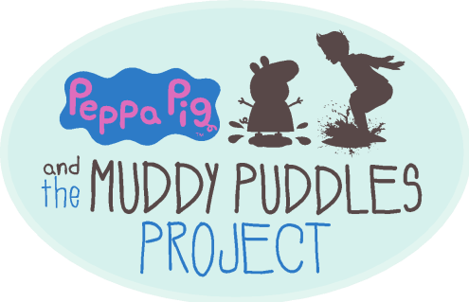

Cindy Campbell FOR IMMEDIATE RELEASE
Ty Louis Campbell Foundation
Muddy Puddles Project
ccampbell@superty.org
(917) 287-6299 (cell phone)
www.MessFest.org

Muddy Puddles Project Celebrates Thirteen Years of
Kids Being Kids in Honor of Those Who Can’t at Mess Fest

CARMEL, NY, March 25, 2026 – On Saturday, August 1, the thirteenth annual Mess Fest will take place at Kiwi Country Day Camp in Carmel, NY. The Muddy Puddles Mess Fest was inspired by Ty Louis Campbell, whose dying wish was to jump in a muddy puddle before he passed away from brain cancer at age 5.

Before he passed away, Ty Louis Campbell’s greatest wish was to jump in a muddy puddle just like Peppa Pig. “When he told me he wanted to jump in a muddy puddle, I was overwhelmed with how simple his wish was, and consumed by grief knowing I could never make it come true for him,” said Cindy Campbell, Ty’s mom. “When he passed away just days later, I received hundreds of beautiful photos from moms around the world who were letting their kids jump in muddy puddles for him, and I started to envision a way to keep that tradition alive by hosting an event that embodies all the fun activities he dreamed of, while benefiting important childhood cancer research to help others like him.”

Before he passed away, Ty’s cancer treatments prevented him from so many simple joys of childhood that are often taken for granted. What started as a blog post by Ty’s mom, begging parents everywhere to let their kids jump in muddy puddles in his honor, resulted in a movement that inspired joy in children and parents. This culminated in a huge fundraising event appropriately named Mess Fest. Families have been coming from all over the tri-state area to enjoy a day of messy fun ever since.

Mess Fest is a day filled with every messy activity imaginable- splatter paint, pie tosses, water balloons, slime time, party foam, slip n’ slide, and of course, a giant mud pit. The day of fun and childlike silliness brings together a community of support for kids like Ty who have lost or are still fighting their battle with cancer.

Over the past twelve years, Mess Fest has attracted more than 17,000 attendees. The events have raised a cumulative $850,000 for childhood cancer research through the Ty Louis Campbell Foundation. It requires about 150 volunteers each year just to run the event, many of whom attended as young children years ago and who are now volunteering as teens. Mess Fest is a reminder of all that the Muddy Puddles Project has accomplished, not only through the funds raised to improve cancer treatments, but also the happiness it has brought to so many people by reminding them to embrace the joys of childhood in honor of Ty’s one simple wish.

“I couldn’t think of a better legacy to build in memory of my little boy, who just wanted the chance to be a regular kid,” said Campbell. “It’s a beautiful reminder of just how quickly our kids grow up, and how important it is to do everything we can to make sure that every kid has the chance to do so.”

The annual fundraiser relies on sponsorship support and in-kind donations to offset the cost of the event and ensure 100% of proceeds from ticket sales support their mission to fund childhood cancer research. For more information, and to get tickets, visit www.MessFest.org.

About The Muddy Puddles Project
The Muddy Puddles Project is a celebration of children and childhood. It was inspired by Ty Campbell, a little boy who absolutely loved Peppa Pig and dreamed of jumping in muddy puddles just like her when his cancer was cured. The project embodies the act of kids being kids in honor of those who can’t.

At its core, The Muddy Puddles Project is a vehicle to remind parents to stop sweating the small stuff; but it is also a fundraising platform for the Ty Louis Campbell (TLC) Foundation in support of childhood cancer research. In 2017, The Muddy Puddles Project became the official charity partner of Peppa Pig, enabling the nonprofit to meet more families, far and wide, and raise awareness for childhood cancer.

About The Ty Louis Campbell Foundation
Founded in September 2012, The Ty Louis Campbell (TLC) Foundation is a nonprofit organization that funds innovative research specifically geared toward the treatment of the deadliest childhood cancers (including brain and spinal cord tumors). The organization seeks less toxic, more effective treatments that are specifically designed for children fighting cancer. Their ultimate mission is to help fund the intelligence and technology that will uncover new ways to more effectively treat children with cancer. For more information about the foundation, visit www.thetlcfoundation.org.

INSTAGRAM: @MUDDYPUDDLESPROJECT
INSTAGRAM: @TLCFOUNDATION
FACEBOOK: www.facebook.com/TLCF.org
FACEBOOK: www.facebook.com/MuddyPuddlesProject/
TWITTER: @TLCFOUNDATION

