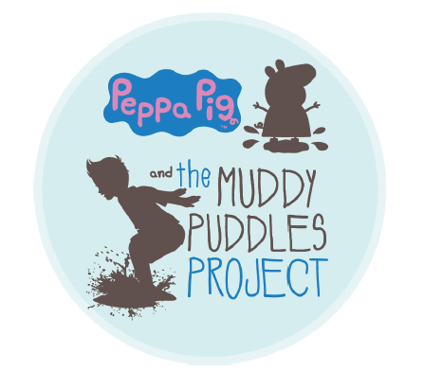
CONTACT: INSERT DATE
HOST’S NAME
PHONE
EMAIL

MUDDY PUDDLES “WELLY WALK” COMING TO INSERT TOWN OR COMMUNITY
Residents Will Raise Funds for Childhood Cancer Research and Family Support

Jumping in muddy puddles is a demonstration of the simple joys that childhood can bring.

I’m reaching out today to share information about an exciting fundraising campaign to benefit children battling cancer through The Muddy Puddles Project.

A Welly Walk is an organized nature walk fundraiser geared toward children that aims to celebrate kids being kids in honor of those who can’t.

In an effort to support the project while having fun, ADD NAME OF YOUR PRESCHOOL, CLUB OR OTHER GROUP HERE will host a Welly Walk Fundraiser to support pediatric cancer research.

Children participating in the Welly Walk fundraiser will enjoy the sights, sounds and smells of nature, while jumping in muddy puddles along the way! This simple act of childhood is encouraged to honor all children who are otherwise unable to do so.

WHAT: MUDDY PUDDLES WELLY WALK

A simple stroll in your wellies (rain boots) where children can enjoy nature and jump up and down in muddy puddles.

WHEN: INSERT DATE
INSERT TIME

WHERE: ADD COMPLETE ADDRESS HERE
The Muddy Puddles Project celebrates kids being kids, and all the silly and fun aspects that come along with it, to honor all kids who are battling cancer. By raising money for the Muddy Puddles Project, NAME OF PRESCHOOL, CLUB OR OTHER GROUP will support their efforts to fund childhood cancer research that has the potential to save lives.

INSERT YOUR NAME HERE said: “[Add a quote to explain what inspired you to take part in the campaign, and any unique activities you may have planned].”

“Welly walks allow children to discover and explore the world around them, while helping others,” said Cindy Campbell of the Ty Louis Campbell Foundation, home to The Muddy Puddles Project. “We are thrilled that so many children are taking part in their very own Muddy Puddles Welly Walk! By jumping in muddy puddles like Peppa Pig and raising money for the Muddy Puddles Project – they will help us get one step closer to curing childhood cancer.”
Any school or youth organization can sign up to take part in their very own Welly Walk at www.MuddyPuddlesProject.org. The website provides a toolkit full of fundraising ideas and tips for great walks and activities indoors and out.

About the Muddy Puddles Project
The Muddy Puddles Project is a celebration of children and childhood. It was inspired by five-year old Ty Campbell, a little boy who absolutely loved Peppa Pig and dreamed of jumping in muddy puddles just like her when his cancer was cured. The project embodies the act of kids being kids in honor of those who can’t.

At its core, the Muddy Puddles Project is a vehicle to remind parents to stop sweating the small stuff; but it is also a fundraising platform for the Ty Louis Campbell (TLC) Foundation in support of childhood cancer research. After Ty lost his battle with cancer, his parents committed to finding ways to fund innovative research geared toward safer, more effective treatment of various childhood cancers. It is the perfect vehicle to engage children in philanthropy because it encourages them to have fun while doing good.

For more information, visit wwwmuddypuddlesproject.org or follow on Facebook and Instagram @MuddyPuddlesProject.

###

