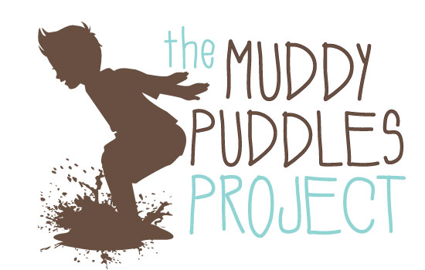
CONTACT:
The Ty Louis Campbell Foundation INSERT HOST’S CONTACT
Cynthia Campbell INFORMATION HERE
(845) 204-5447
thetlcfoundation@gmail.com

MUDDY PUDDLES “MESS FEST” COMING TO INSERT TOWN OR COMMUNITY
Residents Raise Funds for Childhood Cancer in Honor of SuperTy Campbell

When Ty Campbell passed away in October 2012, his parents launched The Muddy Puddles Project in his honor. The project encourages parents to let their children have more fun, and it involves a series of localized events called “Muddy Puddle Mess Fests.”

In an effort to support the project while having fun, ADD NAME OF YOUR TOWN HERE residents will host a Muddy Puddle Mess Fest on insert date, time and location here. Members of the community were inspired by Ty’s story after reading about his fight against cancer on superty.org, where his mother maintains a blog.

HERE WE ENCOURAGE YOU TO INSERT DETAILS ABOUT THE UPCOMING EVENT. ALSO, BRIEF, PERSONAL COMMENTARY ON HOW TY HAS INSPIRED YOU TO HOST THIS EVENT IS WELCOME.

WHAT: MUDDY PUDDLES MESS FEST

A fun, family-focused celebration of kids being kids, in honor of those that can’t

WHEN: INSERT DATE
INSERT TIME

WHERE: ADD COMPLETE ADDRESS HERE

About The Muddy Puddles Project
Five-year old Ty Campbell fought cancer for more than half his young life. He often talked about how jumping in a muddy puddles was the thing he wanted to do most when he was cured. That idea alone, the joy found in the simple act of jumping in a muddy puddle, is a perfect demonstration of what childhood is supposed to be all about. The Muddy Puddles Project is a celebration of kids being kids in honor of those that can’t.
It is a collection of photos and inspirational stories posted to The Muddy Puddles Project website in honor of Ty and all children battling cancer, and it is a series of events that embrace the same concept. This celebration of childhood is a therapeutic reprieve for parents and an opportunity for kids to have more fun while they still appreciate what that means.

-MORE -

About The Ty Louis Campbell Foundation
Founded in September 2012, The Ty Louis Campbell (TLC) Foundation is a volunteer-run nonprofit organization that funds innovative research and technology specifically geared toward the treatment of the deadliest childhood cancers (including brain and spinal cord tumors). The organization seeks less toxic, more effective treatments that are specifically designed for children fighting cancer. Their ultimate mission is to help fund the intelligence and technology that will uncover new ways to more effectively treat children with cancer. For more information about the foundation, visit www.thetlcfoundation.com.

###

